**TABLE BOOKING APP**

**INTRODUCTION**:

Welcome to our Table Booking App, the ultimate solution for hassle-free restaurant reservations! With our intuitive platform, you can effortlessly discover, book, and manage your dining experiences. Say goodbye to long wait times and uncertainty – our app empowers you to explore a diverse array of restaurants, check real-time table availability, and secure your spot in just a few taps.

Whether you're planning a romantic date night, a family celebration, or a business rendezvous, our user-friendly interface ensures a seamless journey from search to reservation. Experience the convenience of modifying or canceling reservations at your fingertips and receive timely notifications to stay informed. Join us in elevating your dining adventures as we redefine convenience, choice, and culinary satisfaction. Download the Table Booking App today and embark on a new era of dining convenience!

**PRE-REQUISITIE:**

To develop a full-stack table booking app using AngularJS, Node.js, and MongoDB, there are several prerequisites you should consider. Here are the key prerequisites for developing such an application:

**Node.js and npm**: Install Node.js, which includes npm (Node Package Manager), on your development machine. Node.js is required to run JavaScript on the server side.

Download: <https://nodejs.org/en/download/>

Installation instructions: <https://nodejs.org/en/download/package-manager/>

**MongoDB**: Set up a MongoDB database to store hotel and booking information. Install MongoDB locally or use a cloud-based MongoDB service.

Download: <https://www.mongodb.com/try/download/community>

Installation instructions: <https://docs.mongodb.com/manual/installation/>

**Express.js**: Express.js is a web application framework for Node.js. Install Express.js to handle server-side routing, middleware, and API development.

Installation: Open your command prompt or terminal and run the following command: npm install express

**Angular:** Angular is a JavaScript framework for building client-side applications. Install Angular CLI (Command Line Interface) globally to create and manage your Angular project.

Install the Angular CLI globally by running the following command:

npm install -g @angular/cli

ng version -You should see the version of the Angular CLI printed in the terminal if the installation was successful.

**Start the development server:**

To launch the development server and see your Angular app in the browser, run the following command: ng serve / npm start.

The Angular CLI will compile your app and start the development server.

Open your web browser and navigate to http://localhost:4200 to see your Angular app running.

**HTML, CSS, and JavaScript**: Basic knowledge of HTML for creating the structure of your app, CSS for styling, and JavaScript for client-side interactivity is essential.

**Database Connectivity:** Use a MongoDB driver or an Object-Document Mapping (ODM) library like Mongoose to connect your Node.js server with the MongoDB database and perform CRUD (Create, Read, Update, Delete) operations.

**Front-end Framework:** Utilize Angular to build the user-facing part of the application, including products listings, booking forms, and user interfaces for the admin dashboard.

**MAIN COMPONENTS USED IN TABLE BOOKING APP:**

**1. Landing Page:**

The app opens a welcoming landing page.

A prominent search bar allows users to input their desired location or restaurant name.

**2. Restaurant Listings:**

After searching, users are presented with a list of restaurants that match their criteria.

Each restaurant card displays the restaurant name, cuisine type, rating, and a thumbnail image.

Users can click on a restaurant card to view more details.

**3. Restaurant Details:**

The restaurant details page shows more information about the selected restaurant.

It includes the restaurant's address, contact information, opening hours, and a description.

Users can see the menu, read reviews, and browse images of the restaurant's ambiance.

**4. Table Availability:**

Within the restaurant details page, users can check the availability of tables.

A calendar widget lets users select the date and time for their reservation.

Available time slots are highlighted.

**5. Making a Reservation:**

Users can choose the number of guests and select a preferred table size.

The app displays available tables based on the user's preferences.

Users can click on a table to proceed with the reservation.

**6. User Authentication:**

If not already logged in, users are prompted to log in or create an account.

New users can register with their email or social media accounts.

**7. Reservation Confirmation:**

Once a table is selected, users are presented with a reservation confirmation screen.

They can review the reservation details, including the restaurant, date, time, and number of guests.

A "Confirm" button finalizes the reservation.

**8. Reservation Management:**

Users have a dashboard where they can manage their reservations.

They can view upcoming reservations, make modifications, and cancel bookings.

**9. Notifications:**

Users receive notifications about their reservations, reminders, and any changes.

**10. User Profile:**

Users can access their profile, where they can update personal information, view reservation history, and manage preferences.

**11. Help and Support:**

A dedicated section offers FAQs, troubleshooting tips, and contact details for customer support.

**12. Search Filters:**

Users can refine their restaurant search using filters like cuisine type, price range, and ratings.

**13. Maps Integration:**

Users can view restaurant locations on a map and get directions.

**14. Payment Integration (Optional):**

If the app supports in-app payments, users can securely enter payment details to confirm reservations.

**15. Ratings and Reviews:**

Users can leave reviews and ratings for restaurants they've visited, contributing to the app's community.

**16. Logout:**

Users can log out from their accounts to ensure privacy.

The key to a successful user interface is simplicity and intuitive design. Use clear icons, buttons, and labels to guide users through the booking process. Incorporating appealing visuals, like images of restaurants and their dishes, can also enhance the user experience. Remember to keep the design consistent and responsive across different devices to ensure a seamless user journey.

Top of Form

**Benefits of Restaurant Booking App:**

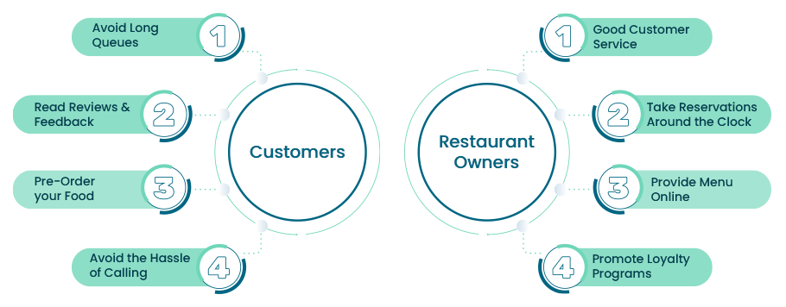

benefits of restaurant booking system development for customers and restaurant owners:

**Customers:**

**Avoid Long Queues:**

One of the major benefits is that users don’t need to stand in long queues outside the restaurant. Using your restaurant booking app, they can easily select their meal slot, book a table, and even pre-order their food. This also provides restaurants with insights into the estimated number of customers for the day to manage staff and food accordingly. It also minimizes food wastage.

**Read Reviews and Feedback:**

Customers can check reviews and feedback from other visitors, which gives them an insight into hygiene, food quality, serving manners, and more, helping them make quick decisions.

**Pre-Order your Food:**

If customers have already decided what they are going to eat, they can easily pre-order their food. There is no need to wait for someone to come and take their order, and it even helps the kitchen staff make necessary preparations. In this matter, restaurant businesses should implement and provide a positive experience to the customers.

**Avoid the Hassle of Calling:**

Customers don’t need to call the restaurant to book a table, know the menu, give any special instructions if needed, etc. With the help of restaurant table booking apps, they can easily do all the tasks independently as all information will be available in the app. This reduces unnecessary hassle and provides an overall great user experience.

**Restaurant Owners:**

**Good Customer Service:**

Providing all the necessary information in the app helps restaurants to provide users with a smooth experience. They can provide users with all the necessary things they might have mentioned while making a reservation. Moreover, the pre-order feature works as a boon for restaurants as it saves plenty of time of ordering after entering the restaurant and helps businesses to work in the best possible way. So, when you develop a restaurant reservation app, don’t miss out on this feature.

**Take Reservations Around the Clock:**

With the help of the mobile app, you can easily take reservations 24/7. Customers can make reservations when they plan, and you can accept or reject them according to your availability. No need for direct interaction with customers and less back and forth communication.

**Provide Menu Online:**

You can provide a complete menu in the app that helps users view and pre-order if needed while making reservations. This helps restaurant staff to prepare necessary things beforehand and even avoids food wastage.

**Promote Loyalty Programs:**

Run special campaigns and provide necessary discounts, which boost your restaurant business. Moreover, you can provide your users with offers, discounts, notify first premium users, etc. these things will help you to keep your customers engaged and keep coming back to you.

There is no limit to the benefits which restaurant booking apps can provide to customers and restaurant owners. When developing an application, you need a technical partner who helps you complete the custom development of restaurant booking applications. Going further, let’s see how to develop a restaurant reservation app that is user-friendly.

**Design Features:**

Let’s discuss some of the major features you should consider while developing a restaurant booking app. Herein, I’ve highlighted features needed according to your different user-base:

**Admin:**

**Secure Sign-In**: This is the basic feature and must be needed when you start to develop restaurant reservation app. Admin can login into their account by entering their credentials and authorizing them. Once done, they can access their entire account to see the list of their visitors and restaurants and do more in it.

**Approve or Reject Vendors:** Upon login, admin can see a complete detailed list of registered vendors/ restaurants. Further, they can verify and authenticate restaurants and, based on it accept or reject the restaurant from listing.

**Manage Vendors:** Admin can efficiently manage all the vendors. They can view the complete menu, feedback received from each restaurant, and other confidential information.

**Manage Customers:** Admin can view the customers’ first and last names, manage them efficiently, and attend to any concerns.

**Approve or Reject Restaurant Request:** Herein, once restaurant owners are authenticated and approved, they can register their restaurant. Further, upon authentication, the admin can approve or reject the restaurant request.

**Restaurant Owners:**

**Signup/ Login:** Restaurant owners can login or sign up for your application to use it further. After login they can view their entire dashboard, where they can add, update, and delete their restaurant details, menu, can view feedback from their users, and more.

**Register Restaurant:** Upon signup, restaurant owners can register their restaurants, add all necessary details, upload menus, add all required legal documents, etc., for admin to cross-check and accept or reject restaurants.

**Manage Restaurant Owner Profile**: Once the restaurant owner has logged in, they can view the dashboard, view all table bookings, payment status, time of arrival of each customer, and more. They can easily manage their entire profile.

**Configure Restaurant Timings:** From their dashboard, vendors can enter their day-wise working hours from their dashboard, special timing for festive seasons, or special events. These changes will reflect in the front-end to their users.

**Instant Booking**: If the restaurant owners enable this feature, they don’t need to accept or reject the booking upon getting a customer reservation. It will be accepted automatically and will notify the restaurant owner.

**Offers and Packages for Customers:** Vendors can carry out varied marketing activities, run campaigns, provide discounts and offers to their customers. They can promote this on your app and send users SMS when needed.

**View Reviews and Feedback**: Restaurant owners can view and approve the reviews and feedback from their customers. In turn, it helps other customers to know their customer service and food quality.

**Customers:**

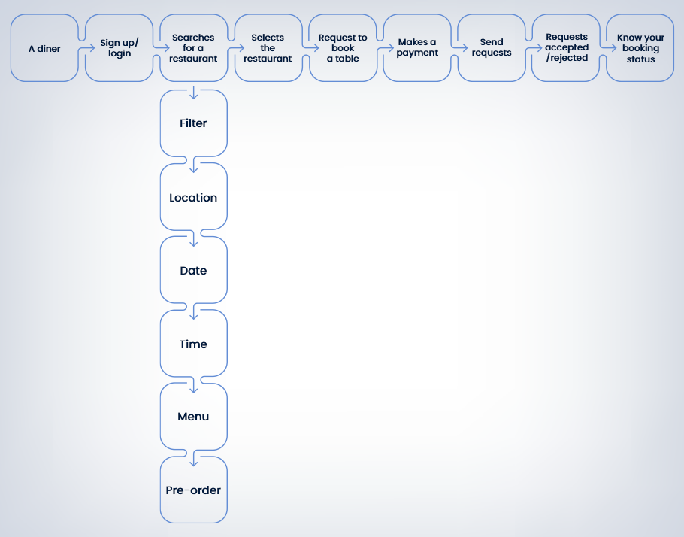

**Login:** Customers can login to their account and view a list of restaurants, feedback, cost of booking the table, select the number of diners, and more.

**User Profile:** Upon login, users can search restaurants, view lists, create a wish list of restaurants they want to visit, manage their entire profile, add and update their details.

**Secure Payment:** Once the user has selected the restaurant, they can select the number of diners, make in-app payments, and book a table. You should have a secure payment gateway.

**Wallet Management:** Users can also debit and credit money from their bank account in the in-app wallet. This helps to make quick and easy payments without needing to add a card or bank details every time.

**GPS Based Navigation:** Users can hassle-free navigate to their desired restaurant.

Reservation Confirmation: Once users have reserved a table and made a payment, they will get confirmation via SMS, providing full transparency and necessary information to users.

**CONCLUSION:**

In conclusion, our Table Booking App redefines the way you experience dining by putting the power of choice and convenience directly into your hands. With a user-friendly interface and a vast selection of restaurants at your fingertips, you can effortlessly plan memorable meals for any occasion. No more waiting on hold, no more uncertainty about table availability – our app streamlines the reservation process, letting you focus on the joy of dining out.

Whether you're a food enthusiast seeking new culinary experiences or a restaurant owner aiming to enhance customer service, our app creates a bridge that connects diners and establishments seamlessly. From browsing through enticing menus to securing a reservation with a simple tap, our app ensures that your dining experience is smooth, efficient, and tailored to your preferences.

Join us in embracing a new era of dining convenience and indulge in the pleasures of great food, ambiance, and company without the usual hassles. Embrace the future of dining with our Table Booking App – where every reservation becomes a memorable occasion.

**TEAM MEMBERS:**

1. THANUSRI S
2. PRIYAADHARSHINI VS
3. KAMALI S
4. NIKITHA LAKSHMI J